Guide for Adding Folders To STM Project

1] Right Click on Project, choose Import

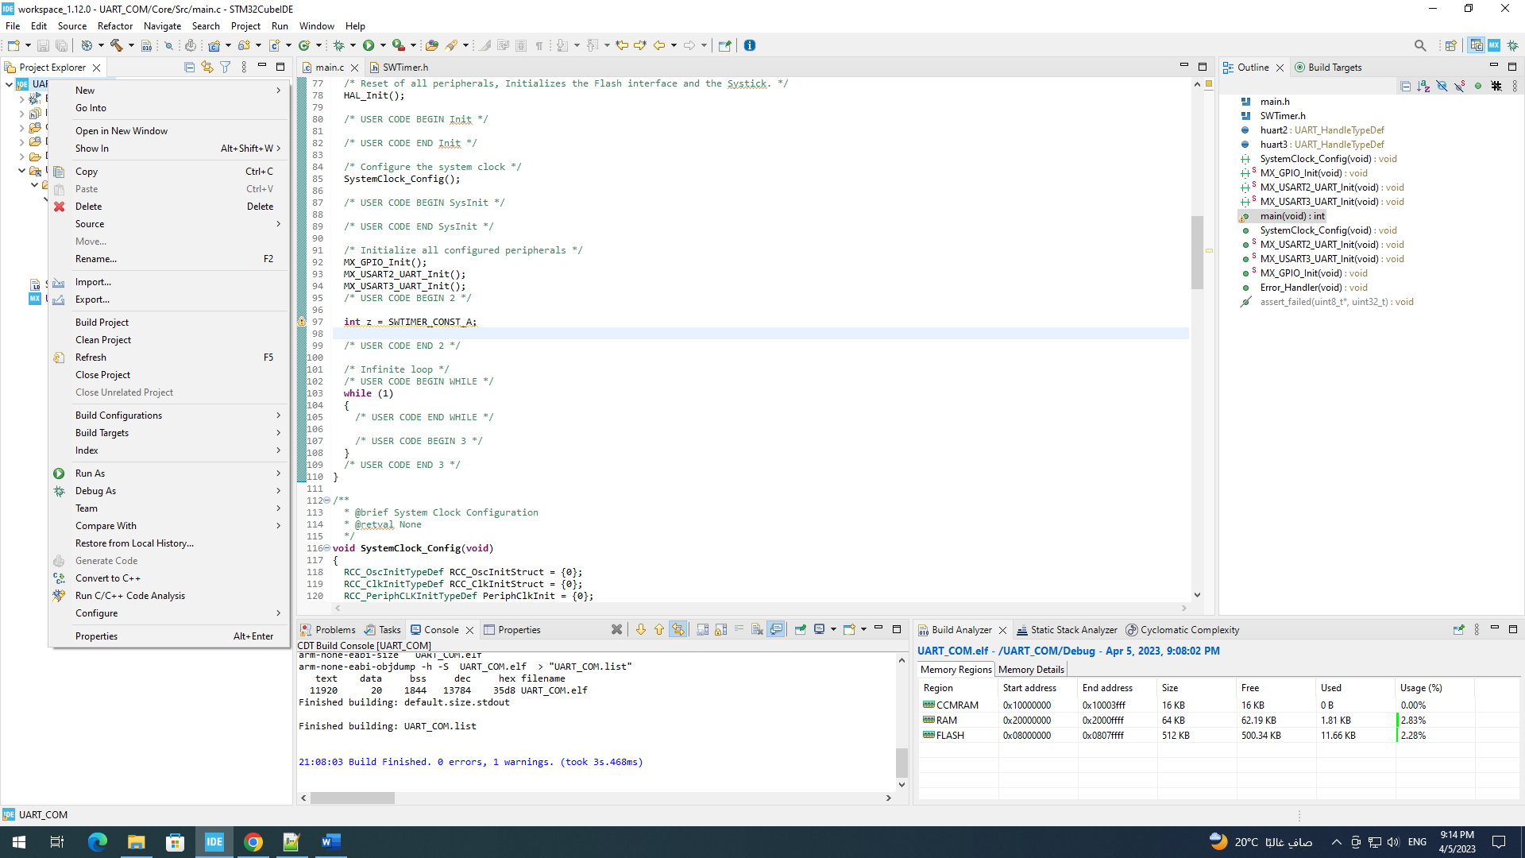

2] Choose File System  
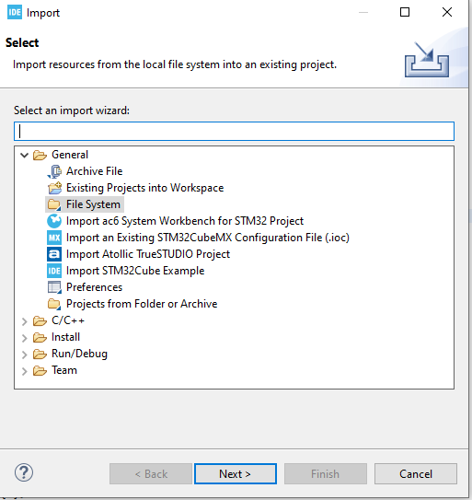

3] Navigate to Folder,  
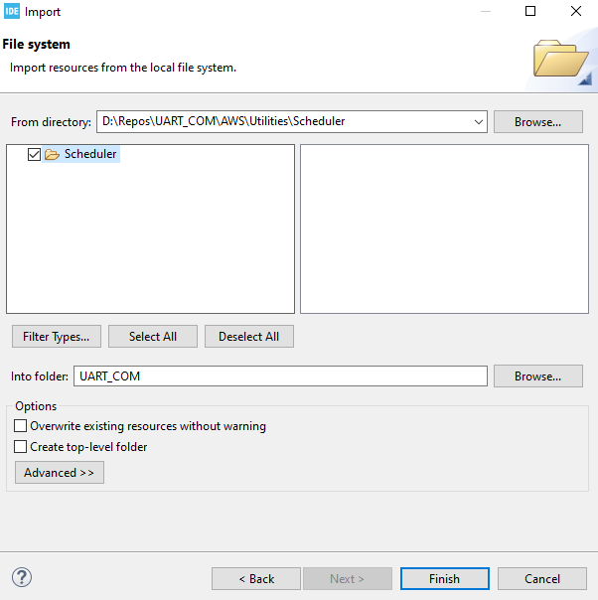

4] Click on Advanced, and choose to create links in workspace and create link location relative to project location

